Enterprise computing
Assessed exercise
Adrián Gómez Llorente - 0904327G

Index of content
Introduction 3
2 Current Architecture 3
2.1 Easyprint4U 3
2.2 PrinterSupplies 4
2.3 A1Servicing 4
3 Efficient business processes 4
3.1 Customer Orders from placing to delivery 4
3.2 Managing service personnel 5
4 Information integration 6
5 Proposals for development 8
5.1 Identify strategies 9
5.2 Identify requirements 9
5.3 Determine IT Initiatives 10
6 Enterprise application integration 11
6.1 Application requirements 11
6.2 Security requirements 11
6.3 Develop the architecture 12
7 New enterprise architecture 13
7.1 Current environment specification 13
7.2 Conclusions about current environment 15
7.3 Defining the new architecture 15
8 Security policy 16
8.1 Security in technology 16
8.2 Roles and privileges 17
8.3 Security good manners 17
9 New printer market conclusion 18

Introduction
Is sure that Alan's businesses have a lot of problems with many things across the 3 companies, for example, information integration and cross data.
In this document a possible solution for all of these problems is exposed and also new market niches for the new printer because of it's not correctly target in the academic market.

Current Architecture

Easyprint4U
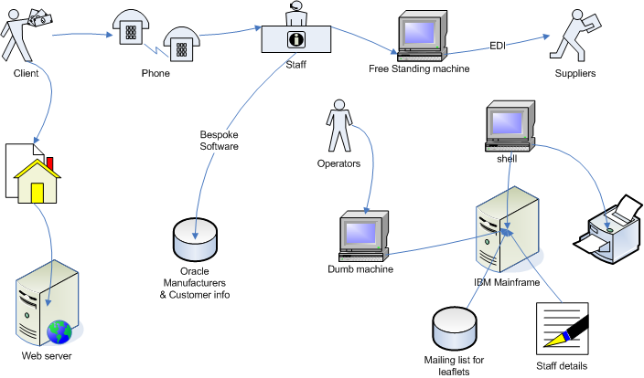
Important details about previous architecture are:
- Website is static and is only for information
- Client only can make purchases using phone
- Staff details are saved in plain text files
- Suppliers are informed using EDI from a free standing machine
- Info about manufacturers, leaflets and customers is in different servers with differend ways to access it.

PrinterSupplies
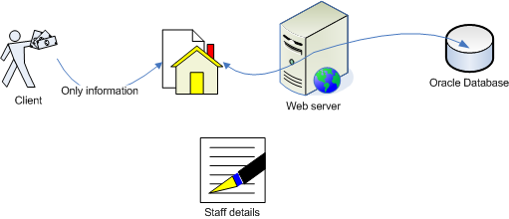
Important details are:
- Website only offer information and cannot be used for purchases
- Web server and database server are connected between them and clients without security
- Staff details are stored using papers

A1Servicing
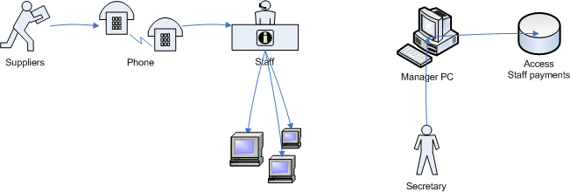
Important details are:
- Service personnel is contacted by phone, memos and notices on boards
- Staff store invoices in their PC in My Documents folder
- Bills are created by a Secretary and stored in an Access DB without backup

Efficient business processes

Customer Orders from placing to delivery
This process is not really improved so we are going to make it more efficient with this solution.

Current process
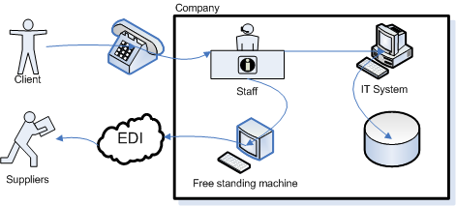
Some problems have been identified in the current process, like:
- Clients can only make a purchase through the phone
- Information of purchases is duplicated, once to update it into the database and second one to inform suppliers from a free standing machine, so that staff has to work twice and information may be inconsistent.

New proposed process
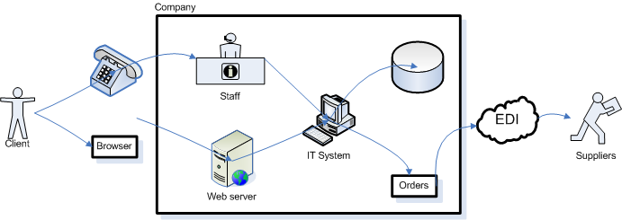
In the previous diagram some solutions have been applied to solve previous problems to improve current process for purchases:
- Clients can make a purchase through phone or by internet using a new website with e-commerce
- Information is only written once in the IT System by Staff or Web server, so time spent and inconsistency have been improved, and this information is used to be stored in the database and to generate an order to the suppliers using EDI.

Managing service personnel

Current process
For managing service personnel and their payments this architecture is used in the system and is also used a manually one based in the us of papers:
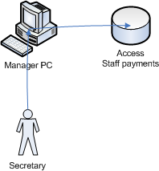
And something has to be detailed:
- There is no backup for staff payments.
- There is not a security policy because secretary access with the password of the manager to the database through the manager pc.

New proposed process
Previous problems have been detected before in the current process, so that a new solution is offered to resolve these problems:
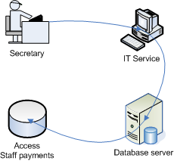
With these modifications some problems have been resolved, let's see details of the new architecture:
- IT Service provides a way to connect with a database server using a security policy, moreover it can be used by many people at the same time.
- Database server provides access to an Access database but it may be used as an interface for connecting to other kind of databases, moreover it has all data replicated in RAID HD.

Information integration
Most important thing for a company is its data, this data is important because if it's modified, updated, and operated it turns into information, and correct information used by correct people is the most powerful tool for a company.
But in these 3 companies, they have a lot of data but is not stored in the correct way and many times is not available for necessary people, that's why a change is needed to get this:
- Integrates information in data servers avoiding papers as much as possible.
- Reducing corrupted data created by the use of spreadsheets, because spreadsheets is one of the most important source of errors.
- Provide a security policy to be sure that correct people is only accessing to some information needed.
- Give a 24/7 access by using an intranet.
- Apply all of these changes reducing changes in current data sources as possible.

Current information system
Before giving a solution the current system must be checked to look for important errors
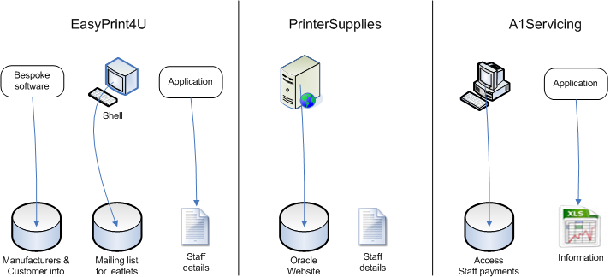
In previous diagram we can see that:
- All information is isolated from each company
- A1Servicing is currently using spreadsheets
- Staff details in printer supplies are stored using papers
- Any information is backed up

New information system
For all the reasons above, a new solution is offered to resolve all the problems and improve the system.
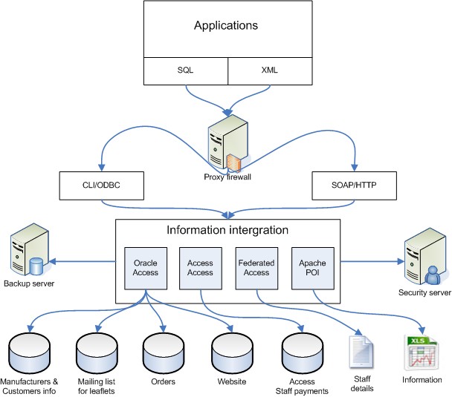
In the previous diagram we can see the new information system, let's see the new details:
- Papers are right now not used through the whole company so workers will have to be taught to use new applications installed
- Spreadsheets are not used directly so errors can be corrected before saved because an application is used to modify them using an access/modify interface (Apache POI)
- There is a security server to check workers privileges and a proxy firewall to stop hackers broke into the system
- All data is backed up into a backup server that uses RAID HD to guarantee that modifications are saved at the moment, moreover additional back up servers can be added.
- Applications are connected to information through an intranet.

Proposals for development
According to the SAIM methodology first step to apply it is the identification of possible proposals for developments that should be carried out, during this chapter some of them are going to be explained.
To do this we will follow next steps:
- Identify strategies
- Identify requirements
- Determine IT initiatives

Identify strategies
- EasyPrint4U
  - Update the current IT System including information integration and connections
- PrinterSupplies
  - E-Commerce secure system
  - Computerize the company
- A1Servicing
  - Improve service personnel visits
  - Get data integration

Identify requirements
- Easyprint4U
  - System: Database replication
  - System: Update EDI Machine
  - Emp: Update staff addresses
- PrinterSupplies
  - User: Request orders using a web system
  - Emp: Work with staff details
- A1Servicing
  - Emp: Real time communication with service personnel
  - System: Hold visits and calculate efficient routes
  - User: Cancel appointments
  - System: Backup information
 |  |  | Requirements
 |  |  | Easyprint4U |  |  | PrinterSupplies |  | A1Servicing
 |  |  | 1 | 2 | 3 | 1 | 2 | 1 | 2 | 3 | 4
Strategies | Easyprint4U | 1 | + | + | +
Strategies | PrinterSupplies | 1 |  |  |  | +
Strategies | PrinterSupplies | 2 |  |  |  |  | +
Strategies | A1Servicing | 1 |  |  |  |  |  | + | + | +
Strategies | A1Servicing | 2 |  |  |  |  |  |  |  |  | +
As can be seen in the previous table, every strategy is integrated with one or more requirements, so that, we can assume that these requirements have to be done to get strategies.

Determine IT Initiatives
The IT Initiatives are:
  - Web based intranet inventory maintenance system
  - Update EDI Machine
  - Automatic order generator to suppliers
  - E-Commerce system
  - Intranet Staff Payroll system
  - Information integrated avoiding spreadsheets
  - Customer Relationship Management System with central database
  - Visiting routes system
  - Real time communication with service personnel using PDA and 3G
  - Backup information
 | IT Initiatives
Requirements |  | 1 | 2 | 3 | 4 | 5 | 6 | 7 | 8 | 9 | 10
Requirements | 1.1 |  |  |  |  |  |  |  |  |  | +
Requirements | 1.2 |  | +
Requirements | 1.3 |  |  |  |  | +
Requirements | 2.1 |  |  |  | + |  |  | +
Requirements | 2.2 |  |  |  |  | +
Requirements | 3.1 |  |  |  |  |  |  | + | + | +
Requirements | 3.2 |  |  |  |  |  |  |  | +
Requirements | 3.3 |  |  |  |  |  |  | +
Requirements | 3.4 |  |  |  |  |  |  |  |  |  | +
As can be seen in the previous table all requirements are satisfied with the proposed IT Initiatives, so these are the Initiatives that must be done to guaranty that the company gets its strategies.

Enterprise application integration

Application requirements
Some requirements are needed to get an enterprise application integration, in fact previous IT Initiatives can be used to determine these requirements, so previous application modifications must be described:
- Web based intranet inventory maintenance system
  - Management of inventory
  - Ability to control orders
  - Automatic generations of orders to suppliers in real time
- E-Commerce system
  - Connection to product database
- Intranet Staff Payroll system
  - Accessing to staff data in any format
- Customer Relationship Management System with central database
  - Allow customers to modify assignments
  - Real time advising to company

Security requirements
- Secure system to exchange orders between suppliers
- Secure pay system for e-commerce
- Secure authentication and identification in e-commerce
- Privileges must be controlled to avoid free accessing to all information
- Secure authentication and identification to modify assignments

Develop the architecture
All the applications used through 3 companies are going to use the same information because they are going to be connected to a main IT service that will provide an API to work with all data stored in current databases.
This way all accesses are going to use a main server that can apply a security policy to guarantee authorization and identification of the users.
Moreover, information will be guaranteed because of a replication of the information thanks to a data server that will backup all changes made.
So that, applications are going to be installed like can be seen in next diagram:
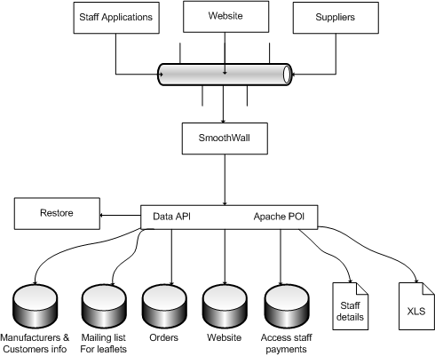
Let's see what's each application shown in the previous diagram:
- Staff applications: They are applications installed in each PC used by company staff. It will be developed using C# or Java and they will implement a security interface for accessing and different operations to work with data.
- Website: Will be a web portal for information about the company and e-commerce using order tracking, while offer an enterprise solution for the 3 companies giving the possibility to an user to get a new product or make an assignment and modify it. Ii will be developed using a dynamic language like PHP or Java servlets.
- Suppliers: Will be a desktop application or a web based system connected to the central server that provides an easy way to all data about orders. Will be developed using Java, C# or PHP and Java servlets if it's a website.
- Smoothwall: Is a linux distribution that provides a powerful firewall that will controls every access to main data servers.
- Restore: Is a linux distribution that offer an easy way for backup and restore. This application will be used together with a RAID HD in important data servers.
- Data API: Will provide an interface for an easy data accessing.
- Apache POI: Is an API that provides different operations ready to use with XLS and other Microsoft Office formats.

New enterprise architecture

Current environment specification
Some of the items that compose current environment have been described before, but we are going to give here an overview about all of this things.
To give this overview we are going to review each company through next topics:
- Current role of integration technology
- Current environment meeting business needs
- Key participants

Easyprint4U
Here we show the same diagram was posted before:

Current role of integration technology
As can be seen in the previous diagram technology is not integrated because there is too many servers and mainframes and they are all connected to different applications installed in different free standing machines. So that, staff personnel have to use different PC to get work done.

Current environment meeting business needs
This company is dedicated to sell products, so they need as many possible ways for selling items, right now only phone way is offered so they should have other way like a web-based one.
Moreover, orders must be introduced twice in the system and this increase time spent on it, reducing the possibility of a fast delivery and a good attendance to customers.
Leaflets system should be improved to get a more automatic one, because right now all of information is stored in an individual server without backup and without a security policy and way to use it is really manual.

Key participants
- Arthur Wilson – Head IT
  - Jack Jones – Legacy system expert
  - Frank Pike – New Computing Science graduate
  - Joe Walker – Technician

PrinterSupplies
Current architecture is shown in next diagram:

Current role of integration technology
Current environment is integrated but staff details are stored using papers so every time they want to update them or work with them they are making a lot of mistakes, that's why a new system is needed to store this information to guaranty the integrity of the information.

Current environment meeting business needs
One of the needs of this business is that they want to implement a secure e-commerce system and right now they only have a website for information only.
To build a secure system a protection, like a firewall, may be added between web server and a database server.

Key participants
- George Mainwarning – IT Head
  - James Frazer – Web developer
  - Charles Godfrey – IT Support to staff

A1Servicing
Current environment is:

Current role of integration technology
Technology is not integrated because they need a database server to store all information about payments and orders because right now all of that information is stored in each computer so is replicated and inconsistent.

Current environment meeting business needs
They have several problems with backup information so a new environment must guaranty that information is going to be duplicated to be used in a crash system. Moreover, they need a security policy for modifying staff details.

Key participants
- William Hodges – Head IT
  - Timothy Farthing – System support for windows-based
  - Maurice Yeatman – Software developer

Conclusions about current environment
Once all data about current environment has been achieved the conclusion is that the company is in pre-integration level where:
- Stand-alone systems have to do any work
- There is bottlenecks to complete works because many tasks must be done using one PC
- Is difficult to understand the current environment for new workers.

Defining the new architecture
It's necessary to have a new architecture for the IT Service. This architecture should be at least a Level 2 integration. In this chapter we are going to explain everything needed to get this.

Information interchange standardised and controlled
We have gotten this thanks to use an API for data accessing. This API may be developed using a common language like C# or Java. Any detail about this is given in the application integration.

Central hub used to control information exchange
This is offered by the Data API and the firewall that provides a controlled way for accessing data through an intranet.

Common data model
All data is going to be modelled using an standardised language as XML, but the data API provides this to be done easily.

Security policy

Security in technology
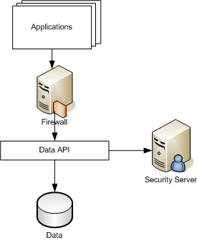
To guarantee the security of the application applications must be connect to API data through a firewall that will stop all unexpected access and then privileges are checked before accessing data in the Security Server.

Roles and privileges
The roles and privileges of the application are:
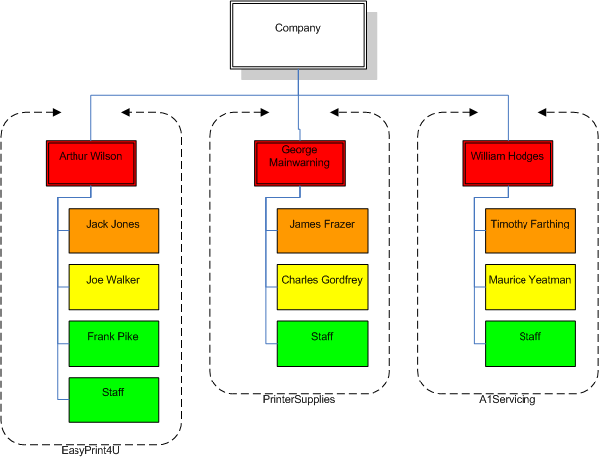
From top top to bottom:
- Red color: Access to every information in the company
- Orange color: Access granted only for view information
- Yellow color: Access granted only to access PC
- Green color: Access granted only to work with certain information according to their job

Security good manners
Some good manners have to be used to guaranty the security of the system
- Passwords will never been shared
- Passwords will be changed every month
- Passwords will be alphanumerical
- Passwords will never been written in the desktop
- One password identify one person

New printer market conclusion
Right now security is guaranteed thanks to the using of many cypher algorithms and is no needed to waste money in paper moreover considering the caring about environment existent , so that, I think that this new printer is not going to be profitable. Anyway technology is not bad and can be applied to other markets but with a restructuring of the system, for example, the technology can be used to get a product to cipher documents into images and decipher these images into documents but not forcing people to print these papers.

